

Cardiovascular clinic

Project no.14



UNDER THE SUPERVISION OF

**Dr. Sahar Fawzi**

|  |  |
| --- | --- |
| ***Name*** | ***ID*** |
| Youmna Tarek | 202001016 |
| Toka Mohamed | 202002280 |
| Laura Mostafa Mohamed | 202001736 |
| Doaa Maged | 202000840 |
| Farah Amr | 202001483 |

***Eng. Mennatallah Abdelsattar***

**Table of Contents**

**1. Introduction5**

1.1 overview5

1.2 Problem definition6

1.3 Proposed Solution6

1.4 Technologies Used7

2. Overall Description7

2.1 List Key Features7

2.2 User Characteristics8

3. Diagrams10

3.1 wireframe10

3.2 ER Diagram14

3.3 High level architecture 15

3.4 Workflow Diagrams16

3.5 Sequence Diagram17

3.6 class Diagram18

3.7 Use case diagrams19

3.8 Use case Scenarios20

3.9 Data flow diagram23

4. Interface25

5. Functional Requirements41

5.1 User Class 1- Receptionist41

5.2 User Class 2- Doctor41

6. Non-Functional Requirements 42

6.1 Availability 42

6.2 Performance42

6.3 Maintainability42

6.4 Usability43

7. Test Cases43

**1. Introduction**

**1.1 Overview:**

If we look at the lives of doctors, there are many challenges. In an industry that is largely disorganized, there is a dire need to give it some structure. Something that is robust, easy to use, and inexpensive. Clinic management software is a solution that can not only overcome these challenges but deal with them intelligently, improving the lives of everyone involved.

**1.2 Problem definition**

* One of the challenges that cardiologists face has been the lack of a specialized heart database. Cardiologists spend a lot of time going through papers and medical records to assess a patient's condition.
* In addition, important data, including medications taken and surgical results were sometimes unavailable when a patient was evaluated at another facility.
* **Paper-based medical records**

The traditional paper-based recording system involves recording patients' health information using physical media such as paper, film, and discs, and storing this recorded information in physical storage devices for retrieval when needed.

* There are some problems with paper medical records:

1. **Duplication:** duplication of paper documents is comparatively costly compared with digital duplication.

* " Duplication means that the patient assigned more than one medical record "

1. **Space:** paper records consume space once massive amounts of information are recorded; they need large warehouses that are stuffed with numerous documents.
2. **searching:** giant records is physically cumbersome, heavy, and often tough to read, perceive and search through for specific information.

* If a doctor wants to manage all of this, the manual process is very tedious. All invoices must be retained. This takes up a lot of space and causes various other problems.

1. **Unavailability of paper record:** A paper record is used just for one task at a time. Even once available, the time and price needed for paper notes to be requested, retrieved then delivered can be costly.
2. **Damage:** paper is prone to damage and degrades over time. It simply may be damaged by human error or natural disasters such as fire. as a result of several facilities keeping only one copy of a paper record, the loss of one record might mean that it's gone forever. Unless it's well cared for.

* These drawbacks of paper medical records are serious and can cause great harm and lead to medical errors.

**- Limited appointment availability, office hours:**

Many care organizations supply a typical set of office hours for patient visits. The clinic that's open between 8 a.m. and 6 p.m. isn't perpetually useful. Patients would like convenient office hours that enable them to go to the doctor outside of their work or faculty schedules

* **The problem with billing and collections:**

Most doctors spend a lot of time comparing the daily bill to the receipt. Often there is a small human error where the amount does not add up. And when patients pay in installments, doctors can't track it. This results in a financial loss for the doctors and wastes valuable time.

**1.3 Proposed solution**

* For space reduction:

Solution: Scan paper copies into electronic form.

* To prevent any paper damage:

Solution:

Electronic medical record of cardiovascular system that collects and manages patient medical data to increase the effectiveness of the healthcare system, has recently been embraced by medical institutions and have emerged as a new technology. This system provides greater flexibility, and efficiency, and is less error-prone for both healthcare practitioners and patients as compared to traditional paper-based health records, which have certain drawbacks including being damaged, lost, stolen, and occasionally not simply available and accessible**.**

* Limited appointment availability:

Solution: Avoid this problem by using the drop-down menu tool. It will be easier for the patients to choose any available appointment that suits their schedule and to have a variety of choices.

* The problem with billing and collections:

Solution: make it optional for the patient to book his appointment online, and this online system will be able to track every financial process without errors and the patient can take back his money in case he wants to cancel his appointment.

Also, the patient can book his appointment in the clinic.

**1.4 Technologies Used:**

* The technologies that are used in this system are:

Desktop Application

C#

Visual Studio

Database SQL

.net frames work

**2. overall Description**

**2.1 List key features**

1)Login: will contain

- Password

-username

-Type (Doctor/Physician or Receptionist?)

*The user should choose Login or Exit.

*If the user logged in the system will open the home page...

2) Home Page: will contain

- Appointment

- Doctors

- Receptionist

-Logout

3) Doctor Page will contain (Doctor profile, Patient overview, Patient history, patient progress sheet, Appointments history, Medication sheet)

Functions:

a) Profile will include (Doctor Name, Doctor ID, Email and biography)

b) patient overview will include (patient name, id, symptoms, radiology tests, prescription)

c) Patient history: will include (patient name, id, DOB, disease, weight, height, medicine, xrays)

4) Receptionist Page: will contain (Receptionist profile, patient info, comprehensive patient history, book Appointments, Appointment history, upcoming appointments, patient referral form)

Appointment history page: will contain (Approved Appointment)

Functions: -Patient (Id-Name) {list from already taken ids of patients}

-Date of reservation

- Calendar (The system will go to approve the appointment if it’s available and hasn’t a clash with another appointment)

Approved Appointment will contain:

-Patient details (ID- Name- Address- phone)

-Appointment Date and Time (...AM or ...PM)

-Doctor Name

-Status (Available or not)

-Action (Approved or not)

-Buttons: Update button and approved button.

**2.2 User Characteristics:**

users of the Cardiovascular clinic system are receptionist and doctor.

* The customer should be comfortable with English language and have prior experience using general desktop applications.
* Users need to be trained to use the application.

**3. Diagrams**

**3.1 Wireframe**

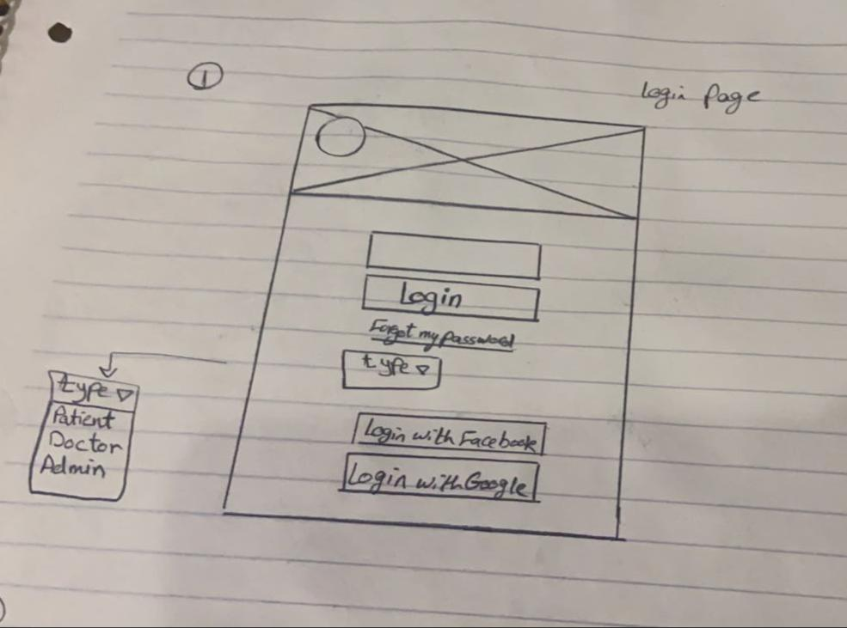

**3.2 Design Database (ERD)**

**3.3 High-Level Architecture**

**3.4 Work-flow Diagrams**

**1)**

**3.5 Sequence Diagram**

-Login

**3.6 Class Diagram**

**3.7 Use case diagram**

**3.8 Use case scenarios**

|  |  |
| --- | --- |
|  | |
| ***Use-case Name*** | ***Login*** |
| ***Actors*** | ***Doctor/Receptionist*** |
| ***Main success scenario:*** | * ***System will prompt the user to enter his sign in information such as username and password.*** * ***User enters his Login information and presses "Login"*** * ***System checks the validity of the sign in information in the database.*** * ***System confirms the validity of the information and redirects the user to use the offered features in the system*** |
| ***Exceptions*** | * ***User entered wrong credentials.*** * ***User doesn’t have an account on the system*** |

Use case 01

|  |  |
| --- | --- |
|  | |
| ***Use-case Name*** | ***Sign up*** |
| ***Actors*** | ***Doctor/Receptionist*** |
| ***Main success scenario:*** | * ***User clicks "Sign up" button once the system opens*** * ***System will display several fields and will prompt the user to fill them with the information such as first name, last name, and password etc...*** * ***User should enter the required information and press "Register" button*** * ***System should validate the entered information.*** * ***System should save the data of the user in the database once the user register*** |
| ***Exceptions*** | * ***User already has an account, so application pops up error message*** |

Use case 02

**3.9 Data flow Diagram**

**4. Interface**

**Login Page**

**This is the first page that appears when the user enters the system, the system is divided into two logins: Doctor login and Receptionist login and then the user go to the dashboard.**



1. **Receptionist Pages**

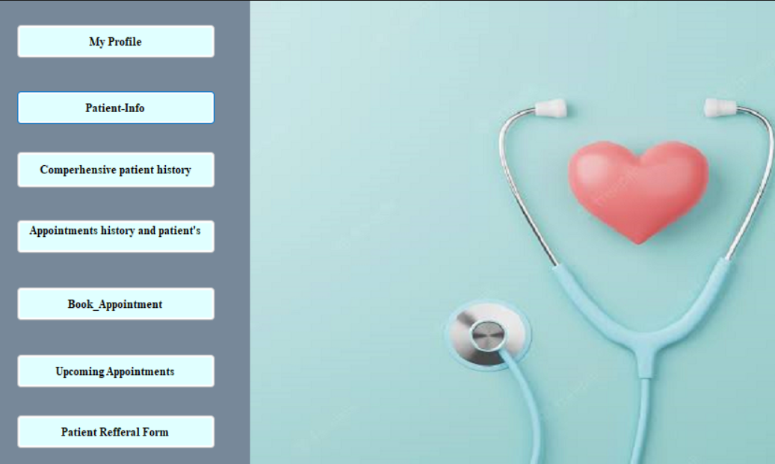

from this page, receptionist will be able to choose whether she wants to view her profile, patient info, comprehensive patient history, Appointments history, to book appointment and view upcoming appointments and patient referral form.

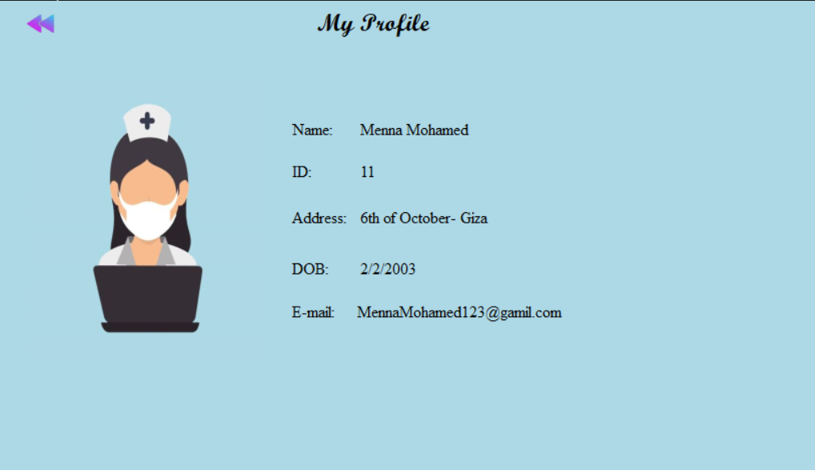

In Receptionist/ My Profile, this page is the profile of the Receptionist that contains his/ her information like: (Name, ID, Address, Date of birth, and E-mail).

At the top of the page, there is a back button to make the patient easily go back to the dashboard.

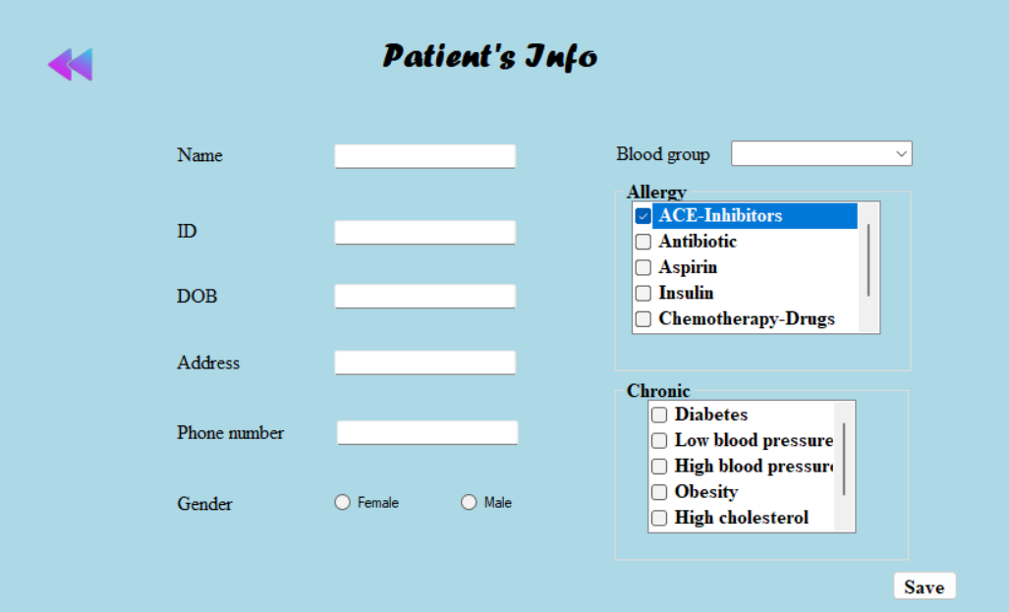

Receptionist can assign patient’s info (his/ her name, id, date of birth, address, phone number, ..etc).

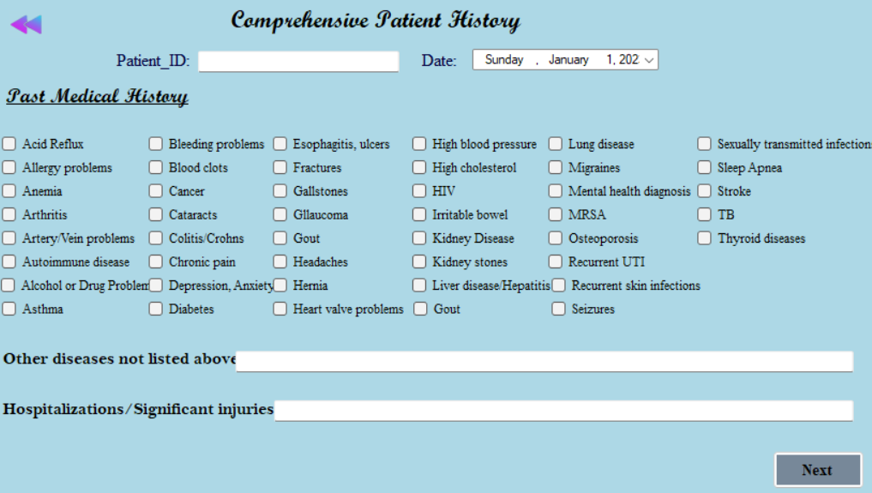

Receptionist can assign comprehensive patient history by asking about past diseases and injuries.

Receptionist can assign comprehensive patient history by asking about past surgeries.

Receptionist can view appointments history and patient’s info

The receptionist can book appointments by entering patient name and id and choosing a specific time to book.

The receptionist can view upcoming appointments.

Receptionist can fill patient referral form.

1. **Doctor Pages**



This is doctor’s dashboard, doctorwill be able to choose whether he wants to view his profile, patient overview, patient’s history, patient progress sheet, patient referral form, appointments history and patient’s info and medication sheet.

In Doctor/ My Profile, this page is the profile of the doctor that contains his information like: (Name, ID, Address, no of visits, E-mail, and biography).

Doctor can view patient overview and assign patient name , id, symptoms, disease, prescription and radiology tests he need.

Doctor can view patient history.

Doctor can view patient progress sheet.

Doctor can fill patient referral form.

Doctor can view appointment history and patient’s info.

Doctor can view medication sheet that contains patient’s name, id, dosage, medicine name, and prescription.

**5. Functional Requirements**

**5.1 Receptionist:**

**1.Title:** my profile.

**Desc:** Receptionist should be able to view her/ his profile.

**2. Title:** patient info.

**Desc:** Receptionist should be able to view patient info.

**3. Title:** comprehensive patient history.

**Desc:** Receptionist should be able to view comprehensive patient history and assign any information.

**4. Title:** Appointments history and patient’s info.

**Desc:** Receptionist should be able to view appointments history and patient’s info.

**5. Title:** book appointment.

**Desc:** Receptionist should be able to book appointments.

**6. Title:** upcoming appointments.

**Desc:** Receptionist should be able to view upcoming appointments for all patients.

**7. Title:** patient referral form.

**Desc:** Receptionist should be able to view and fill patient referral form.

**5.2 Doctor:**

**1. Title:** my profile.

**Desc:** Doctor should be able to view his profile.

**2. Title:** patient overview.

**Desc:** Doctor should be able to view patient overview.

3. **Title:** patient’s history.

**Desc:** Doctor should be able to view patient history.

**4.** **Title:** patient progress sheet.

**Desc:** Doctor should be able to view and fill patient progress sheet.

**5.** **Title:** patient referral form.

**Desc:** Doctor should be able to view and fill patient referral form.

**6.** **Title:** Appointments history and patient’s info.

**Desc:** Doctor should be able to view appointment history and patient’s info.

**7.** **Title:** Medication sheet.

**Desc:** Doctor should be able to view medication sheet.

**6. Non-Functional Requirements**

We examined and measured some quality attributes, which are listed below, based on the testing carried out on our system.

**1. Availability**

* The system should be able to operate 24 hours a day, seven days a week.

**2. Performance**

* The app should be highly efficient that its loading time doesn’t exceed a limit (200 milli sec:1 sec response time limit).

**3. Maintainability**

* The system can be updated later on and be added to the application after.

**4. usability**

* The system should be easy to use by medical staff and should be organized in such a way that user errors are minimized. (Goal)
* Medical staff shall be able to use all the system functions after four hours of training**.**

**7. Test Cases**

|  |  |
| --- | --- |
| **Test Case ID:** Fun_1 | **Test Designed by:** Laura |
| **Test Priority (Low/Medium/High):** High | **Test Designed date:** 12/23/2022 |
| **Module Name:** book appointment | **Test Executed by:** Laura |
| **Test Title:** Verify user ability to book an appointment | **Test Execution date:** 12/23/2022 |
| **Description:** Testing whether the user will be able to book an appointment |  |
|  |  |
|  |  |
| **Pre-conditions:** User has valid username and password.  There is a valid appointment in the appointment database | |
|  | |

|  |  |  |  |  |  |  |
| --- | --- | --- | --- | --- | --- | --- |
| **Step** | **Test Steps** | **Test Data** | **Expected Result** | **Actual Result** | **Status (Pass/Fail)** | **Notes** |
|  |  |  |  |  |  |  |
| 1 | Navigate to book Appointment |  | save order button is disabled. | Receptionist was able to book an appointment with entered information | Pass |  |
| 2 | Select a suitable time | Patient id: 222  Patient name: Asmaa ali  12:00—12:30 pm | Save order button is enabled. |  |  |  |
| 3 | Click the “save” button |  | Order is successfully booked and saved in the database |  |  |  |
| 4 | booking is successfully processed |  |  |  |  |  |
|  |  |  |  |  |  |  |

**GitHub Link:**

[**https://github.com/loraouf/Beating-Spirit-Clinic/tree/master**](https://github.com/loraouf/Beating-Spirit-Clinic/tree/master)**.**